Day 30 - 05th Sept 2025

Task 01:

Create a table using AWS Management Console

10.38 to 10.43

Task 02:

Use all the CRUD operations using AWS Management Console.

10.44 to 10.54

DynamoDb Architecture

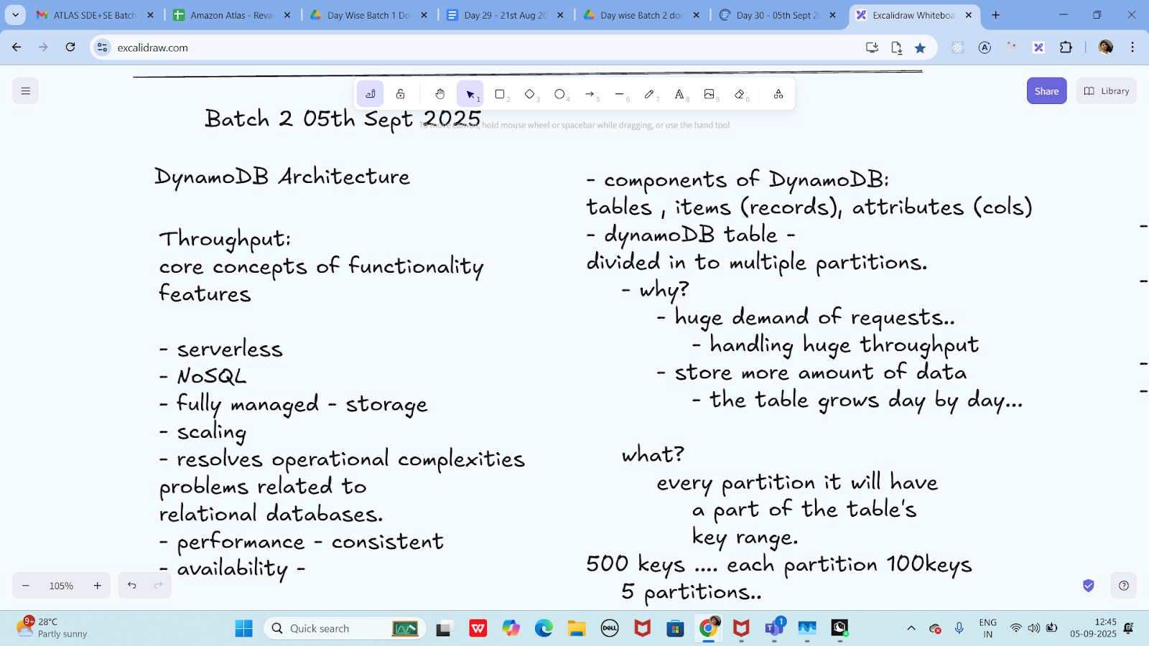

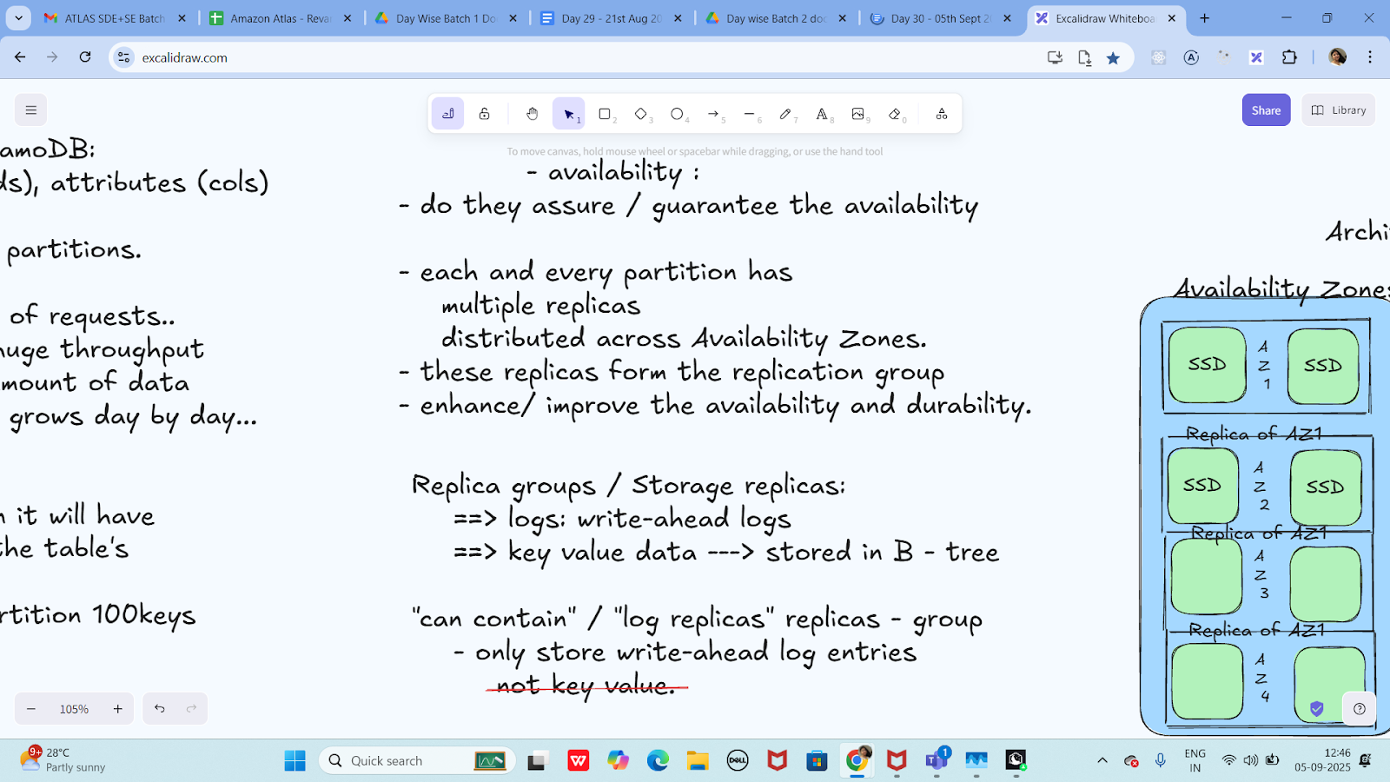

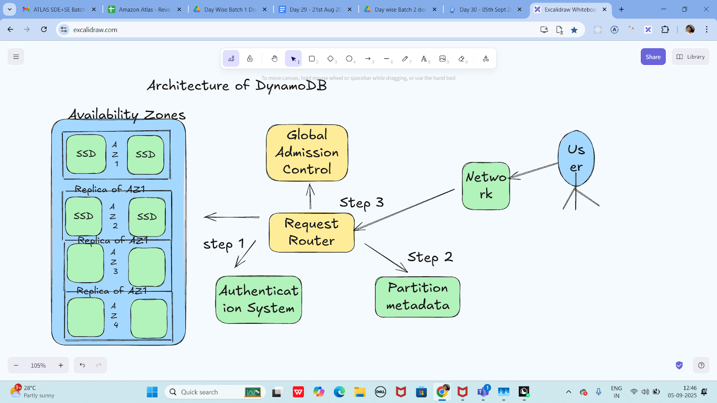

—---------------------------------------------------------------------------------------------------------------------------------------------------------------------------------------------------------------------------------------------------

Info Box:

Projects allocated to batch 2

<https://drive.google.com/drive/folders/1JxEfQiKEiW9hq1YyCkpbGxXkkfoO2PjQ?usp=sharing>

Projects – Google Drive

Doc name is : All projects 10 day plan

sheet name is : Batch2 projects.

Excalidraw Updated at 12.45

<https://excalidraw.com/#json=L2DaHthbxnrfkCyJgmU_Q,odS3e5F5xFW8STWWbJv7IA>

—----------------------------------------------------

Add ons:

Ways to reduce code - dynamodb — doc in Module 4 Dynamodb folder

<https://drive.google.com/drive/folders/19jURMCjQRnl-j56VLupBhuCgkSr7oLrf?usp=sharing>

Amazon AWS dynamoDb doc for reference…

<https://docs.aws.amazon.com/amazondynamodb/latest/developerguide>

CPS-user-stories link

<https://docs.google.com/document/d/1cHdvgX-qlfIHPl4ryMtQOcfcSWZw7Dqv/edit?usp=sharing&ouid=103020917863623365252&rtpof=true&sd=true>

Project doc link..

<https://drive.google.com/drive/folders/1JxEfQiKEiW9hq1YyCkpbGxXkkfoO2PjQ?usp=sharing>